

AHMEDNAGAR JILHA MARATHA VIDYA PRASARAK SAMAJ,

**NEW ARTS, COMMERCE & SCIENCE COLLEGE AHMEDNAGAR**

Department Of Statistics (2020-21)

Project On

**STATISTICAL ANALYSIS OF MATERNAL MORTALITY RATE**

Performed By,

1)Anap Pranit

2)Kokane Shrikant

3) Zend Pushkar

Guided by,

Prof. M.S. Kasture Prof.A.B.Bhasme

Head Of Department Assistant Professor

*INDEX*

|  |  |  |
| --- | --- | --- |
| **SR. NO.** | **TITLE** | **PAGE NO.** |
| 1 | ACKNOWLEDGEMENT | 3 |
| 2 | INTRODUCTION | 4 |
| 3 | OBJECTIVE & TERMS USED | 6 |
| 4 | CHOOSING POPULATIONS & DATA SOURCE | 7 |
| 5 | ABSTRACT OF THE PROJECT | 8 |
| 6 | CORRELATION | 9 |
| 7 | ONE SAMPLE RUN TEST | 10 |
| 8 | TEST FOR NORMALITY(Shapiro test) | 11 |
| 9 | T TEST FOR TWO SAMPLE MEANS | 12 |
| 10 | MATERNAL MORTALITY TATE &PAIRED t-TEST | 13 |
| 11 | INFANT MORTALITY RATE & PAIRED t-TEST | 14 |
| 12 | FEMALE LITERACY RATE & PAIRED t-TEST | 15 |
| 13 | SIMPLE LINEAR REGRESSION MODELS | 16 |
| 14 | RESULTS | 18 |
| 15 | CONCLUSION | 19 |
| 16 | A WAY FORWARD | 20 |

**-: ACKNOWLEDGEMENT :-**

We are sincerely thankful to our teachers for their extended best possible supports and cooperation. They taught us to implement the topics covered in the classroom in the actual world and real life situations.

we are also thankful to all those who helped us in gathering the required details about this project:

we really enjoyed working on this project as our teachers made it an example of

"EDUCATION THROUGH ENTERTAINMENT and team efforts are also appreciated

*INTRODUCTION*

* The ***’Women Empowerment*** ’is the slogan we are hearing since many years. In various fields women are leading the country for example 2 years ago our country’s Defense minister and Foreign minister were ladies at a time but also on the other hand there are many difficulties in their ***social, economic and educational development*** all over the country. Government has implemented many schemes to improve the ***female literacy and their health.*** But how much impact these schemes have made can be seen from the data. The beneficiaries of the these schemes are the ones who really need it also can be seen from the data. Even if these schemes are implemented the ***social conditions and mentality of the society*** is also important. Sometimes, ***strict laws*** are also important for this.
* In this project we **aim** to study the Maternal Mortality Rate in India and different social, economical and educational factors affecting it.
* Maternal mortality in a region is a measure of reproductive health of women in the area. Many women in reproductive age-span die due to complications during and following pregnancy and childbirth or abortion. As per World Health Organization, “Maternal death is the death of a woman while pregnant or ***within 42 days of termination of pregnancy***, irrespective of the duration and site of the pregnancy, from any cause related to or aggravated by the pregnancy or its management but not from accidental or incidental causes. Maternal Mortality Ratio ***(MMR)*** in India was exceptionally high ***in 1990 with 556 women dying during child birth per hundred thousand live births.***
* Maternal health is the condition of ***women health during pregnancy, childbirth and the postpartum period.*** The health of the mother being directly associated with the health of the new born, utmost care to the mother is essential during all the three phases. Motherhood comes to constitute a largely fulfilling experience for women but is unfortunately also a cause for suffering, ill-health or even death for many women.
* Approximately, ***1.38 lakh women were dying every year*** on account of complications related to pregnancy .The ***WHO’S SDG goal till 2030*** is to reduce the global maternal mortality ratio ***to less than 70 per 100 000 live births***.
  + There has, however, been an accelerated decline in MMR in India. ***The last recorded MMR in 2018 is 113.***

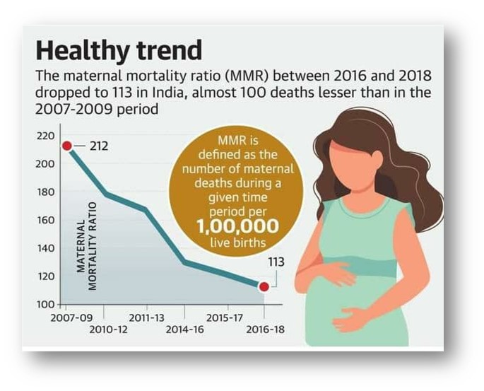

***WHAT IS MMR?***

* + The maternal mortality ratio (MMR) depicts the number of maternal deaths relative to the number of live births and is usually reported as the number of maternal deaths per 100,000 live births. The Maternal mortality rate is defined as the number of maternal deaths in a population divided by the number of women of reproductive age, usually expressed as the number of maternal deaths per 1,000 women.

MMR = $\frac{Number of maternal deaths in population}{Number of women of reproductive age}$*1000

* ***OUR OBJECTIVES***

1. To study the **EDUCATIONAL, SOCIAL, ECONOMICAL andMEDICAL** factors affecting the **MATERNAL MORTALITY RATE.**
2. To find the **CORRELATION** between between MMR and the factors affecting it.
3. To find the **MOST SIGNIFANT** factor amongst them.
4. To analyze the change in **the MMR,IMR and FEMALE LITERACY RATE from 2011 to 2018.**
5. To study **state wise variability** of factors affecting MMR.
6. To find the **way forward.**

* ***TERMS USED***
  + ***Female Literacy Rate:*** *In a country like India, literacy is the main foundation for social and economic growth. When the British rule ended in India in the year 1947 the literacy rate was just 12%. Over the years, India has changed socially, economically, and globally. After the 2011 census, literacy rate India 2011 was found to be 74.04%.*
  + ***Infant Mortality Rate :***  *Is the number of deaths per 1,000 live births of children under one year of age. The****rate****for a given region is the number of children dying under one year of age, divided by the number of live births during the year, multiplied by 1,000.*
  + ***Mean Years of Schooling :*** *Average number of completed years of education of country’s population aged 25 years and older, excluding years spent repeating individual grades.*
  + ***Total Fertility Rate :*** *The number of children who would be born per women (or per 1000 women if she were to pass through the childbearing years bearing children according to a current schedule of age specific fertility rates.*
  + ***Density Of Healthcare Workers:*** *Total number of health care workers including Doctors, nurses, ASHA workers all medical technicians, etc. per lakh population of the state specifies the Density of Healthcare Workers.*
* ***CHOSSING POPULATION***
  + To get the population defined, we decided to take concise and easily approachable data. So the Indian States were taken under study.
  + Total population of the states Andhra Pradesh, Arunachal Pradesh, Assam, Bihar, Chhattisgarh, Delhi, Goa, Gujarat, Haryana, Himachal Pradesh, Jammu and Kashmir, Jharkhand, Karnataka, Kerala, Madhya Pradesh, Maharashtra, Manipur, Meghalaya, Mizoram, Nagaland, Odisha, Punjab, Rajasthan, Sikkim, Tamil Nadu, Tripura, Uttar Pradesh, Uttarakhand, West Bengal was taken for the study.
  + Total No. of states taken under Study=29.
* ***DATA SOURCE:***
  + The collected is purely secondary data.
  + It was collected online from government websites.
  + [Maternal Mortality Ratio (MMR) (per 100000 live births) | NITI Aayog](http://niti.gov.in/content/maternal-mortality-ratio-mmr-100000-live-births)
  + <https://www.pib.gov.in/PressReleasePage.aspx?PRID=1697441>

***ABSTRACT OF THE PROJECT***

* After the collecting the data , the next step was to represent the data in manner to make the analysis simple and more efficient.
* Firstly we have to the **CORRELATION** between the factors affecting MMR.
* After this to check the randomness of the data, we have to perform the **ONE SAMPLE RUN TEST .**
* Then to check the **NORMALITY** of data we will use **SHAPIRO TEST** .
* To check the equality of 2 sample means we have to use **t TEST .**
* The **paired t test** is then used to compare changes in IMR, MMR and Literacy rates from 2011 to 2018.
* Then we will study the quantitative relationship between the variables using **Simple linear regression**.
* ***CORRELATION***

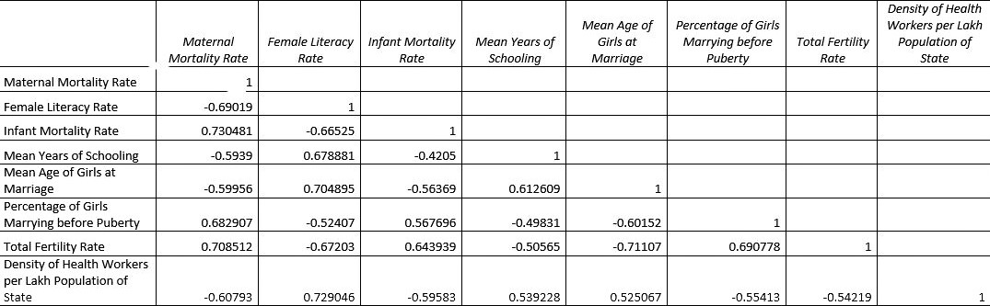

* ***RESULT FROM CORRELATION:***

There is **strong positive correlation** between **IMR and Total Fertility Rate with MMR.** While there is **moderately negative correlation** between **Female Literacy Rate and Density of Healthcare workers with MMR.** Which means that as IMR and TFR increases there are greater chances of increasing MMR significantly. And as Literacy Rate and Density of Healthcare workers increases MMR will decrease significantly.

* ***ONE SAMPLE RUN TEST***

The **one sample run test** is used to test the **randomness** of the given **numeric data**.

We consider,

H0: The given sample is random.

H1: The given sample is not random.

* 1. For MMR: we get R(Total number of runs in arrangement)=**11**  where, **Cα =9 and Cα/2 =21**, So here we **accept Ho**.
  2. For Female Literacy Rate: we get R(Total number of runs in arrangement)=**14**  where, **Cα =9 and Cα/2 =21**, So here we **accept Ho**
  3. For IMR: we get R(Total number of runs in arrangement)=**16**  where, **Cα =9 and Cα/2 =20,** So here we **accept Ho**
  4. For Mean Years Of Schooling: we get R(Total number of runs in arrangement)=***13***

where***, Cα =9 and Cα/2 =21,*** So here we a***ccept Ho.***

* 1. For Mean Age of Girls at Marriage: we get R(Total number of runs in arrangement)=***16***

where, ***Cα =9 and Cα/2 =21,*** So here we ***accept Ho***.

* 1. For Percentage of Girls marrying before Puberty:

we get R(Total number of runs in arrangement)=***13***

where, ***Cα =8 and Cα/2 =20***, So here we **accept Ho**.

* 1. For Total Fertility Rate: we get R(Total number of runs in arrangement)=***6***

where, ***Cα =3 and Cα/2 =10,*** So here we ***accept Ho.***

* 1. For Density of Healthcare Workers: we get R(Total number of runs in arrangement)=***18***

where***, Cα =9 and Cα/2 =21,*** So here we ***accept Ho.***

As, we accept all the considered null hypothesis, we can conclude that, ***all the samples***

***taken under study are random.***

* ***TEST FOR NORMALITY***



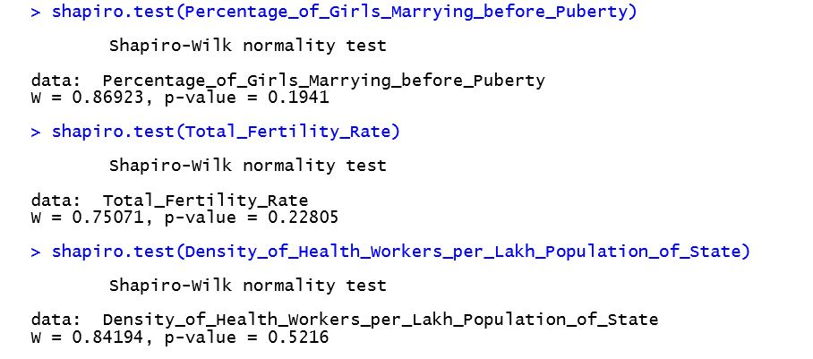

* *Here, as all the* ***p- values are greater than level of significance****, we can conclude that all the factors considered are* ***normally distributed.***
* ***T TEST FOR TWO SAMPLE MEANS***
* To study the equality of two sample means of two independent groups we use unpaired t test.
* Here, to study the equality of the Maternal and Infant mortality rates we run unpaired t test.
* Consider , Ho : Mean Maternal and Infant mortality rates are same.

H1 :Mean Maternal mortality rate is greater than Infant mortality rate.

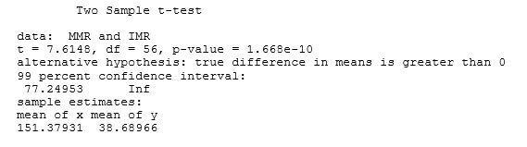

* *The* ***p value*** *here we get is* ***less than that of level of significance****, so we reject Ho and* ***accept the alternative****. Thus, we conclude that the* ***Maternal Mortality Rate(मातामृत्यू दर) in India is more than that of the Infant mortality rate(बालमृत्यू दर) .***
* ***MATERNAL MORTALITY RATE***
* ***PAIRED t-Test***

Paired t-test is used to compare the means of two dependent variables. Here, we have taken MMR of year 2011 and 2018 to study the change in MMR over the Years.

Consider,

Ho=There is no change in MMR over the time span.

H1 =MMR of the year 2011 is greater than of the year 2018.

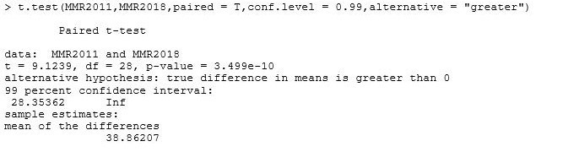

* So here, we have got the p-value which is less than the level of significance. Thus, we reject Ho and accept the alternative hypothesis. And we can conclude that the MMR has reduced significantly throughout the span.
* ***INFANT MORTALITY RATE***
* ***PAIRED t-Test***

Paired t-test is used to compare the means of two dependent variables. Here, we have taken IMR of year 2011 and 2018 to study the change in IMR over the Years.

Consider,

Ho=There is no change in IMR over the time span.

H1 =IMR of the year 2011 is greater than of the year 2018.

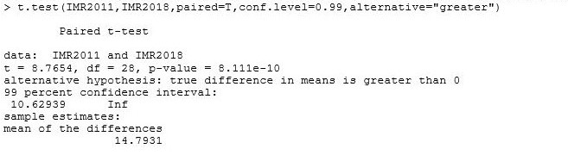

* So here, we have got the ***p-value which is less than the level of significance***. Thus, we reject Ho and accept the alternative hypothesis. And we can conclude that the ***IMR has reduced*** throughout the span.
* ***FEMALE LITERACY RATE***
* ***PAIRED t-Test***

Paired t-test is used to compare the means of two dependent variables. Here, we have taken Female Literacy Rate of year 2011 and 2018 to study the change in Literacy Rate over the Years. Consider,

Ho=There is no change Female Literacy Rate in over the time span.

H1 = Female Literacy Rate of the year 2011 is less than of the year 2018.

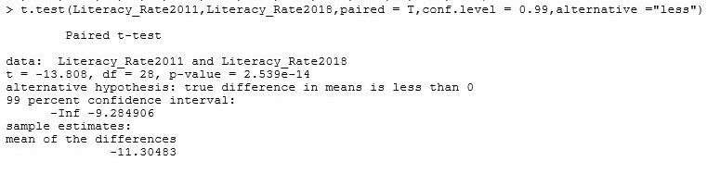

* *So here, we have got the* ***p-value which is less than the level of significance****. Thus, we reject Ho and accept the alternative hypothesis. And we can conclude that the* ***Female Literacy Rate has increased*** *throughout the span.*
* ***SIMPLE LINEAR REGRESSION MODEL***
* The simple linear regression model is used to study the impact of the independent variable on the dependent variable.
* To study the impact of considered variables on the MMR, we will build the separate four models.
* MMR=βo+ β1 *IMR+ε
* MMR=βo+ β1 *Female Literacy Rate+ε
* MMR=βo+ β1 *Percentage of Girls Marrying before Puberty +ε

MMR=βo+ β1 *Density of Health Workers +ε

The above are the models we will be studying next. where, βo = Intercept and β1= Slope and errors(ε) are iid N(0, ${\text{σ}}^{2}$).

* ***SIMPLE LINEAR REGRESSION MODEL***

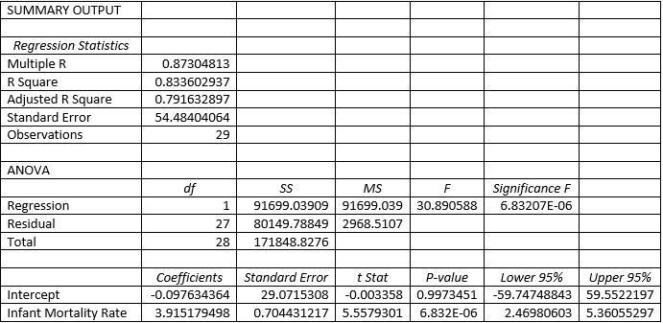

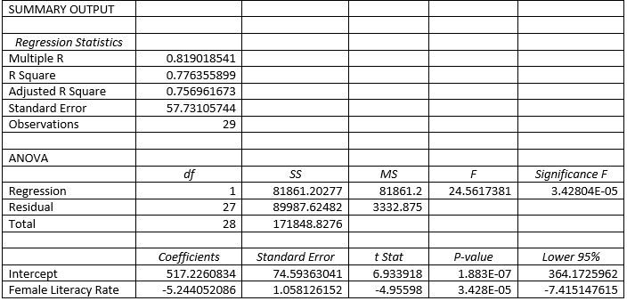

* ***SIMPLE LINEAR REGRESSION MODEL***

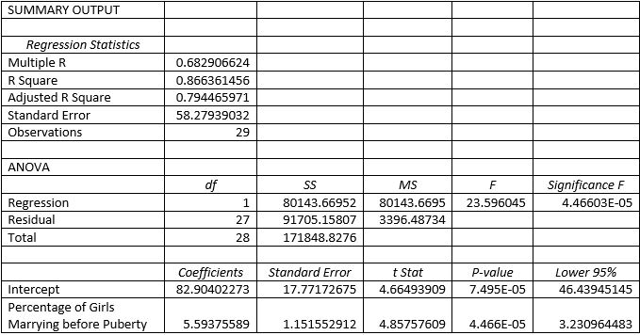

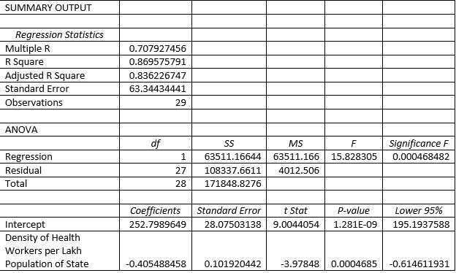

* From these models, we observe that, **F statistics is greater than the significant F value** so we can say that in all the models, **regression as a whole is statistically significant.**
* The coefficient of determination ($r^{2}$) around **87.3% , 81.9% , 86.6% and 86.9% of variation in MMR is explained** by the explanatory variables IMR, Female Literacy Rate, Percentage of Girls Marrying before Puberty and Density of Health Workers per Lakh Population of State respectively.
* The Regression Models from the above ANOVA tables can be written as:
* MMR= -0.097634364+3.915179498*(IMR)
* MMR= 517.2260834 -5.244052086 *(Female Literacy Rate)
* MMR= 82.90402273 + 5.59375589 *(Percentage of Girls Marrying before Puberty).
* MMR= 252.7989649 -0.405488458 *(Density of Health Workers per Lakh Population of State)
* From the above models, we can say that
  + As the IMR increases by 1 unit, the MMR will increase by around 4 times of that.
  + As the Female Literacy Rate increases by 1 unit, the MMR will decrease by more than 5 times of that.
  + As the Percentage of Girls Marrying before Puberty by 1 unit, the MMR will increase by more than 5 times of that.
  + As the Density of Health Workers per Lakh Population of State by 1 unit, the MMR will decrease by around half the times of that.

As , ***p-values for all the models are less than the level of significance*** ,we can conclude that the factors that is IMR, Female Literacy Rate, Percentage of Girls Marrying before Puberty and Density of Health Workers per Lakh Population of State are ***all contributing in the changes occurring in the MMR.***

* **RESULTS**
* The MMR and IMR has reduced significantly from 2011 to 2018.
* Whereas the Female Literacy Rate improved and the growth is satisfactory.
* Factors like Female Literacy Rate and Percentage of girls marrying before Puberty are the most significant and are affecting most amongst others.
* Average Maternal Mortality Rate is higher than that of the Average Infant Mortality Rate of the country.
* Factor Density of Healthcare Workers has the most variability while Total Fertility Rate and the Mean years of Schooling are the factors with least variability.
* ***CONCLUSION***
* After studying and interpreting the data it is very much clear that the Maternal Mortality Rate and the Infant Mortality has reduced. The Female Literacy rate being the most affecting factor. Also the density of the healthcare workers has increased significantly which has also been reflected into the number of mortalities.
* The various Schemes like “**BETI PADHAO BETI BACHAO YOJANA**” implemented by the Central Government of INDIA in 2015 for improving Literacy Rate and the **quality of the education** in Rural as well as urban areas could be considered as the main reason and the GUIDING principle to the every citizen of India to encourage women at every levels for their education. The scheme called as “**SARVA SHIKSHA ABHIYAN**” is being implemented since 2000 has also resulted in this positive sign of decreasing mortality rate. Rate of admitting children both Boys and Girls to the primary schools was around 100% in 2018.
* But unfortunately, the rate decreases to 87% when it comes to admitting children to secondary school and further it falls down to 50% for higher secondary school. Which indicates that around half of the boys and girls after age of 14 to 16 remain deprived of further higher education. This is main concern which we have to concentrate and improve in the recent years to come which eventually will be reflected in the maternal and infant mortality rates,
* If health of girls of ***age 19 to 49*** is considered, ***about 50% to 55%*** of them suffer from ***Anaemia***. To improve the health of girls during of this age scheme ”***KISHORI SHAKTI***” is being implemented.
* Cases of ***marriages of girls before 18*** was very much common till some years back. This results in the marrying before puberty in many cases. But the data shows us the mean age of the girl at marriage has increased to about 21.8 in 2018 from 20.3 in 2011. The marrying before 18 impacts negatively when the child because of the weak mother. ***Malnutrition*** is also result of it and sometimes the child or/and mother succumbs to death due to complications during child birth. Government has implemented “***POSHAN ABHIYAN***” to ***provide nutritional diet to*** the Pregnant women and malnourished children.
* **A WAY FORWARD**
* *The improvement can be seen in the data throughout the years as many NGOs and governments are working for awaring people. A suggestion by the experts is been constantly given to increase the minimum age of marriage for girls to 23 which would impact positively to reduce the mortality rates.*
* *And again “The glass is half filled or half empty” is all up to how one see it. Some steps are taken for the improvement but a lot has to be done and that all rests upon us as one country.*